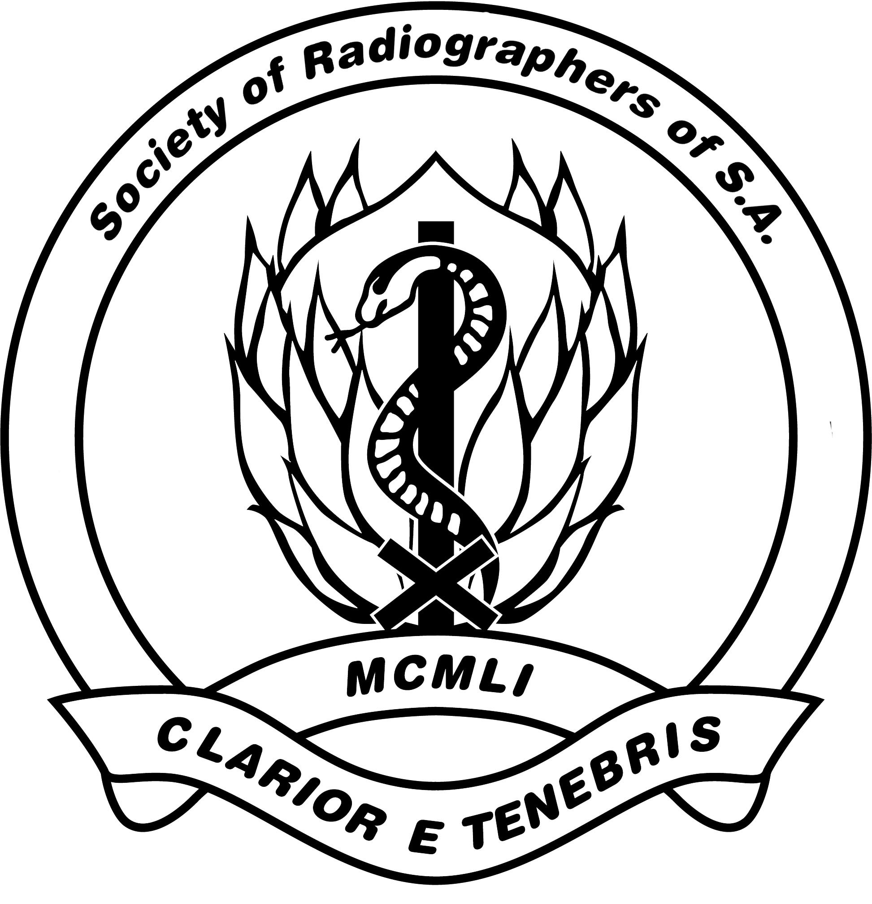

SOCIETY OF RADIOGRAPHERS OF SOUTH AFRICA (SORSA) EDUCATION FUND

The aim of this fund is to encourage members to attain further qualifications for the purpose of professional advancement that will impact positively on clinical service delivery in any category of radiography.

The fund is available to members with suitable registerable qualifications and who have been paid-up full (ordinary) members of the SORSA for not less than four (4) consecutive years.

The following courses offered at South African institutes of higher education can be considered:
- Post graduate qualifications in radiography.
- Post graduate qualifications of not less than 120 credits in relevant fields to improve knowledge and skills for service delivery purposes, (courses could be in human resources / labour relations / risk management / or MBA degree, for example).
- Short courses of not less than 30 credits that are directly relevant to job descriptions of radiographers for clinical service delivery including management knowledge and skills.
- Short courses of not less than 30 credits that are directly related to in-service training and development for improvement of service delivery in any radiographic category.

Criteria for awarding the fund
All applications must be completed on the SORSA fund application form to reach the Administrative Office, P.O. Box 505 Howard Place 7450 before 30 June each year.
The successful applicant will be required to submit a paper on-line for potential publication in The South African Radiographer. Applicants must familiarize themselves with on-line publication requirements : www.sar.org.za

All applications will be screened by the national council education representative for tabling at the next national council meeting.
- An amount of R 2000-00 (two thousand rand) to be awarded annually at the discretion of national council to one recipient only.
- Depending on prevailing economic climate the amount could be increased by between 5% - 10% annually commencing 2011 at the discretion of national council.
- If more than one application is received then, provided all criteria are met, the names of the applicants will be written on blank slips of folded paper and placed in a ‘hat’ for selection of a recipient in the presence of national council.
- National Secretary to inform the successful applicant in writing that:
- 50% of the award will be paid on proof of successful completion of the course;
- balance of the awarded amount will be paid after the article has been peer reviewed and accepted for publication in The South African Radiographer.
- the recipient is responsible for forwarding proof of acceptance of the article for publication in a future issue of the journal to the administrative office for attention national treasurer.
- If there is no recipient for an award from this fund in a particular year/s then the amount is not withdrawn from the investment fund.
- These criteria to be reviewed in every five years i.e. 2015, 2020 etc.

Date of implementation: October 2009

